Important Notice: We are committed to providing you with a safe environment in which to do business, in accordance with all health & safety guidelines and precautionary measures as set out by local authorities.
Africa Oil & Power (AOP) vows to adhere to the advice, regulations and requirements of the relevant public health authorities in respective host countries to ensure that our events operate in accordance with local regulations, while meeting international health and safety standards.
Measures include, but are not limited to: online pre-registration, temperature screening, social distancing, contactless transactions and hygiene protocols.

Guidelines
As we prepare to welcome delegates, speakers, exhibitors and more back to our events in 2021, the following safety measures have been adopted by AOP to ensure a safe and secure return to live events.

All measures are in place to keep you safe

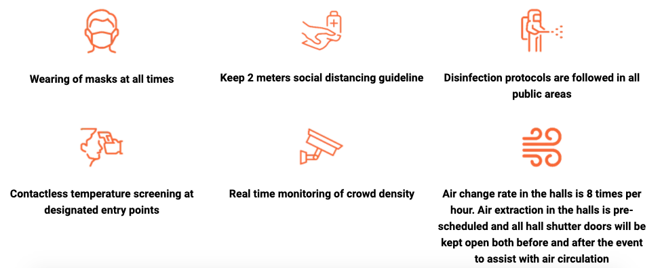
Monitoring of air flow at all times during the event. Venue doors will be open pre and post event on a daily basis to assist with air circulation
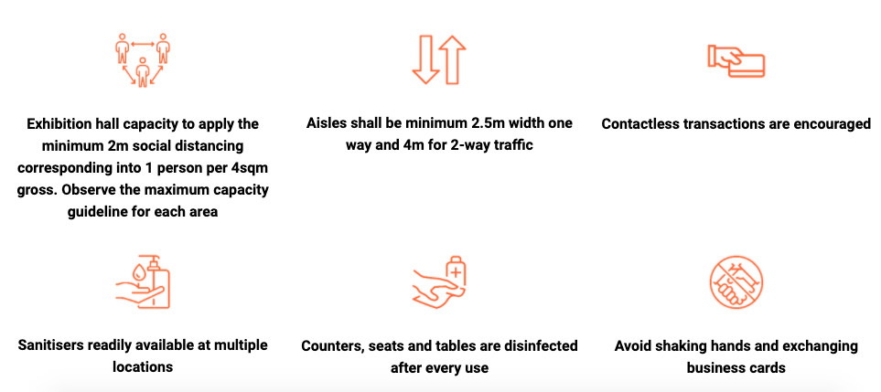
Counters, seats and tables will be disinfected continuously throughout the event

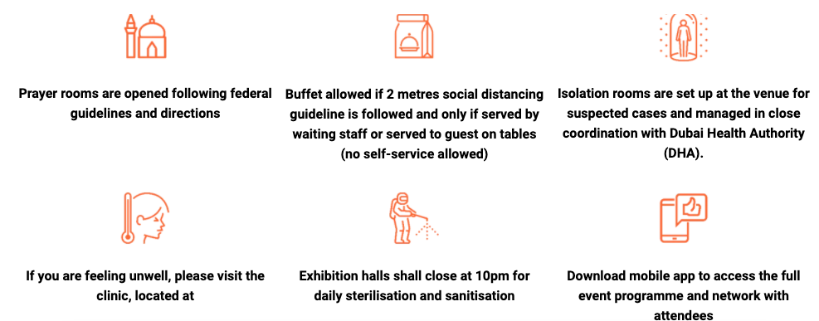

All facilities will be sterilised pre and post event

If you are feeling unwell, report immediately to a medic onsite
A side room for any visitors showing symptoms will be available

CONFERENCE HALL SAFETY MEASURES
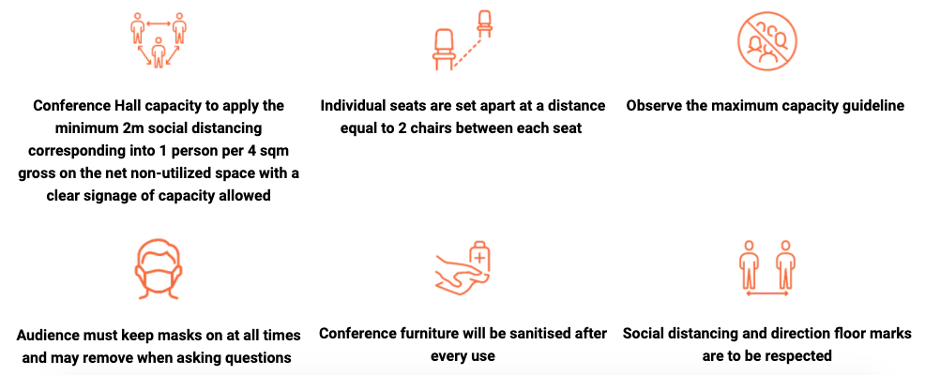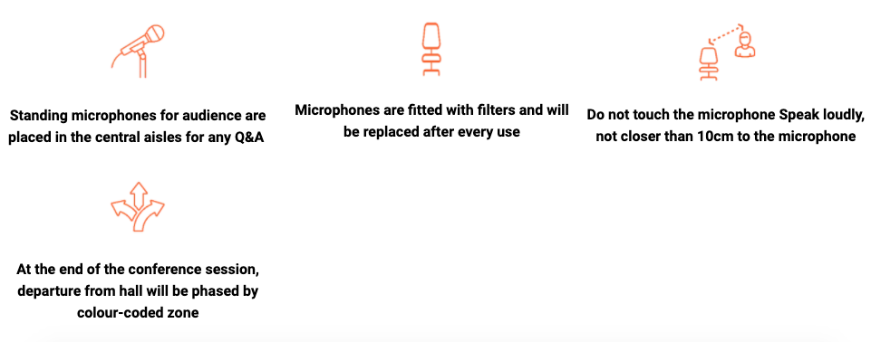

Microphones will be sterilised after use.
Conference furniture will be sanitised after use
Your health is our foremost priority. The event will implement strict precautionary measures, including mandatory facial coverings at all times, social distancing, contactless transactions and general hygiene protocols. We encourage all guests to exercise social responsibility.
*Event health and safety precautionary guidelines subject to change as directed by local authorities.

Stay safe.

